# LABS

The **Labs** tab provides access to all of your lab results contained within the HIE. By default, outpatient lab results are available 48 hours after they are final. Inpatient results are available 36 hours after discharge from the hospital.

Some kinds of lab results may not be included—ask your healthcare provider if a test result is not displayed. Lab results will only be available from participating providers of the HIE.

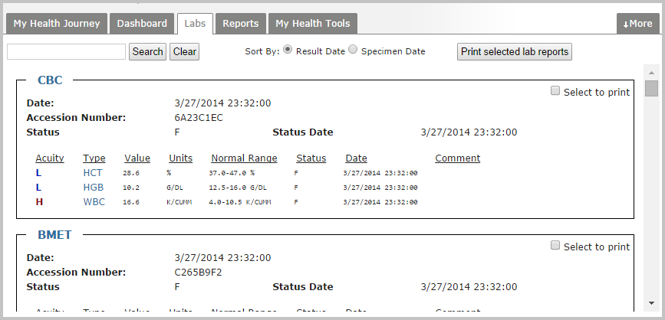

The search boxin the upper leftallows you to search by lab type (such as CBC) or by individual results contained within a report (such as WBC).

Lab results are able to be sorted by the date of final result (*Result Date*) or by the date the lab test was performed (*Specimen Date*).

To print out lab results, select the **Select to print** checkbox at the upper right of each lab result panel to be printed. Then, click the **Print Selected Lab Reports** button next to the search bar.

All reports will be collected into a single document, and sent to a print window in the browser.

